LAB REPORT实验报告
Lab Title | Lab_01_Algorithm |  |  |  | Lab No. | 01
Stud. Name | 蒋云翔 | Major | CST |  | Class
Student ID | 2022102330 |  | Date | 2023/9/23
Lab description/objectives:
Define the polynomial ADT with linked list. Implement the operations of AddPoly() and MultiPoly() to realize addition and multiplication of two polynomials. Design many testing cases and check whether the operations can be executed properly in any case.
Source code:
#include <stdio.h>
#include <stdlib.h>

typedef struct PolyNode* Polynomial;
struct PolyNode {
int coef; // 系数
int expon; // 指数
Polynomial next; //指向下一个node
};

Polynomial CreatePoly() {
Polynomial p, tail, temp; // 设置tail尾节点方便插入新项
int coef, expon;
int flag = 0; // flag用于辅助判断是否是第一个节点
p = (Polynomial)malloc(sizeof(struct PolyNode));
p->next = NULL;
tail = p;
scanf("%d %d", &coef, &expon);
while (expon != -1) { // 输入-1时结束多项式的创建
if (flag == 0 && coef == 0) { // 若第一个node系数为0，则退出循环
break;
}
temp = (Polynomial)malloc(sizeof(struct PolyNode));
temp->coef = coef;
temp->expon = expon;
temp->next = NULL;
tail->next = temp;
tail = temp;
flag = 1; //链表的第一个节点已经安置好，flag设置为1
scanf("%d %d", &coef, &expon); // 继续读取下一个node的系数与指数
}
return p;
}

void PrintPoly(Polynomial P) {
if (!P->next) { // 若链表为空，输出0
printf("0\n");
return;
}

int flag = 0; // 判断是否是第一个非零项
while (P->next) {
if (flag && P->next->coef > 0) {
printf("+"); // 系数为正时输出 "+" 符号
}
if (P->next->coef == 1) { //情况1：系数为1 省略掉1 避免输出如：1x^2的项
if (P->next->expon == 0) { //指数为0 仅输出系数
printf("%d", P->next->coef);
}
else if (P->next->expon == 1) {
printf("%dx", P->next->coef);
}
else {
printf("x^%d",P->next->expon);
}
}
else //其余情况正常处理
{
if (P->next->expon == 0) {
printf("%d", P->next->coef);
}
else if (P->next->expon == 1) {
printf("%dx", P->next->coef);
}
else {
printf("%dx^%d", P->next->coef, P->next->expon);
}
}

// 合并同类项
if (P->next->next && P->next->expon == P->next->next->expon) {
Polynomial temp = P->next->next;
while (temp && temp->expon == P->next->expon) {//循环向下遍历是否有同类项
P->next->coef += temp->coef;
temp = temp->next;
}
}
P = P->next;
flag = 1;
}

printf("\n");
}

Polynomial AddPoly(Polynomial p1, Polynomial p2) {
if (p1->next == NULL && p2->next == NULL) { //链表为空的情况
return NULL;
}
Polynomial front, tail, temp, t1, t2, t;
int sum;
t1 = p1->next; // 多项式1的第一个非零项
t2 = p2->next; // 多项式2的第一个非零项
front = (Polynomial)malloc(sizeof(struct PolyNode)); // 创建结果多项式的头结点
front->next = NULL;
tail = front;
while (t1 && t2) {
if (t1->expon < t2->expon) { //情况1：多项式1的项的指数 < 多项式2的项的指数 把指数小的往后移，输出时结果更美观
temp = (Polynomial)malloc(sizeof(struct PolyNode));
temp->coef = t1->coef;
temp->expon = t1->expon;
temp->next = NULL;
tail->next = temp;
tail = temp;
t1 = t1->next;
}
else if (t1->expon > t2->expon) {//情况2：多项式1的项的指数 > 多项式2的项的指数 把指数小的往后移，输出时结果更美观
temp = (Polynomial)malloc(sizeof(struct PolyNode));
temp->coef = t2->coef;
temp->expon = t2->expon;
temp->next = NULL;
tail->next = temp;
tail = temp;
t2 = t2->next;
}
else {// 情况3：多项式1的项的指数 = 多项式2的项的指数
sum = t1->coef + t2->coef; //指数相同，系数相加
if (sum != 0) {
temp = (Polynomial)malloc(sizeof(struct PolyNode));
temp->coef = sum;
temp->expon = t1->expon;
temp->next = NULL;
tail->next = temp;
tail = temp;
}
t1 = t1->next;
t2 = t2->next;
}
}
while (t1) {//找多项式1多出来的的项
temp = (Polynomial)malloc(sizeof(struct PolyNode));
temp->coef = t1->coef;
temp->expon = t1->expon;
temp->next = NULL;
tail->next = temp;
tail = temp;
t1 = t1->next;
}
while (t2) {//找多项式2多出来的的项
temp = (Polynomial)malloc(sizeof(struct PolyNode));
temp->coef = t2->coef;
temp->expon = t2->expon;
temp->next = NULL;
tail->next = temp;
tail = temp;
t2 = t2->next;
}
temp = front; // 释放头结点
front = front->next;
free(temp);
return front;
}

Polynomial MultiPoly(Polynomial p1, Polynomial p2) {
if (p1->next == NULL || p2->next == NULL) { //乘法运算只要有一个多项式为空 则无法进行 不同于多项式加法
return NULL;
}
Polynomial front, tail, temp, t1, t2, t, p;
int coef, expon;
t1 = p1->next; // 多项式1的第一个非零项
t2 = p2->next; // 多项式2的第一个非零项
front = (Polynomial)malloc(sizeof(struct PolyNode)); // 创建结果多项式的头结点
front->next = NULL;
tail = front;
while (t2) { //多项式2中的每一项与多项式中的第一项相乘
temp = (Polynomial)malloc(sizeof(struct PolyNode));
temp->coef = t1->coef * t2->coef;
temp->expon = t1->expon + t2->expon;
temp->next = NULL;
tail->next = temp;
tail = temp;
t2 = t2->next;
}
t1 = t1->next; //从多项式1的第二项开始
while (t1) {
t = front;
t2 = p2->next;
tail = front;
while (t2) {
expon = t1->expon + t2->expon;//指数相加
coef = t1->coef * t2->coef;//系数相乘
p = front;
while (p->next && p->next->expon >= expon) { // 找到正确的插入位置，并合并同类项
if (p->next->expon == expon) {
p->next->coef += coef;
if (p->next->coef == 0) { // 若系数和为0，则删除该节点
temp = p->next;
p->next = temp->next;
free(temp);
}
break;
}
p = p->next;
}
if (!p->next || p->next->expon < expon) { // 插入新节点(结果多项式链表没位置了or有新的指数)
temp = (Polynomial)malloc(sizeof(struct PolyNode));
temp->coef = coef;
temp->expon = expon;
temp->next = p->next;
p->next = temp;
}
t2 = t2->next;
}
t1 = t1->next;
}
return front;
}

void DestroyPoly(Polynomial p) {//释放多项式链表内存
Polynomial temp;
while (p) {
temp = p;
p = p->next;
free(temp);
}
}

int main() {
Polynomial p1, p2, result;

printf("请输入第一个多项式的系数和指数，以空格分隔（输入-1表示结束）：\n");
p1 = CreatePoly();
printf("第一个多项式为：");
PrintPoly(p1);

printf("请输入第二个多项式的系数和指数，以空格分隔（输入-1表示结束）：\n");
p2 = CreatePoly();
printf("第二个多项式为：");
PrintPoly(p2);

result = AddPoly(p1, p2);
printf("两个多项式相加的结果为：");
PrintPoly(result);

result = MultiPoly(p1, p2);
printf("两个多项式相乘的结果为：");
PrintPoly(result);

DestroyPoly(p1);
DestroyPoly(p2);
DestroyPoly(result);

return 0;
}

Program outputs:
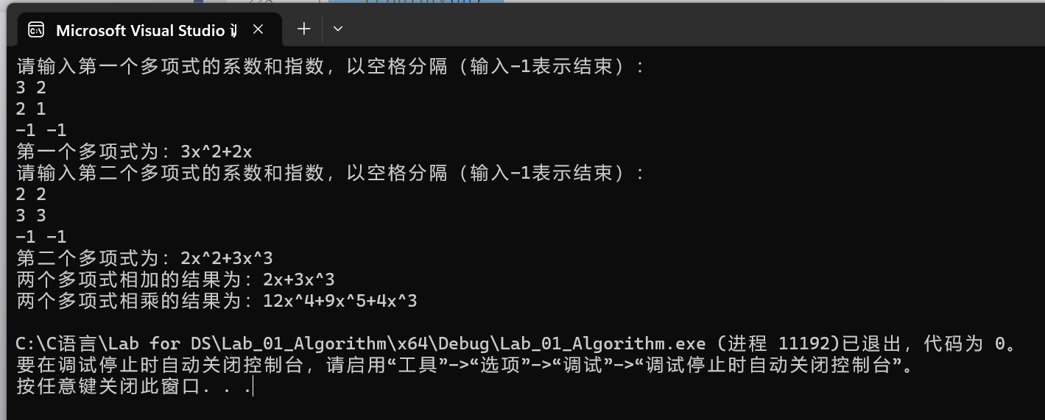
Analysis and Comments:
The most difficult part of this algorithm is to figure out how to merge and output polynomials.
The key point is that sorting based on the coefficients or exponents of the terms in the final polynomial can facilitate our traversing operation.

